EXPERIMENT 3(A)

ROLL NO: 240701826 NAME: GOWTHAM KUMAR PS

Create a prototype with familiar and unfamiliar navigation elements. Evaluate ease of use with different user groups using proto.io

Screen 1 :

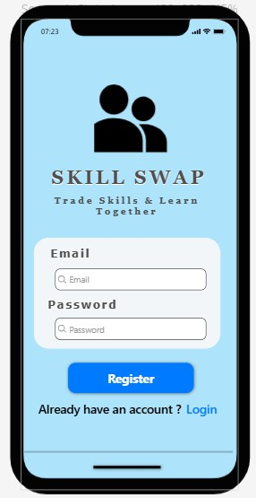

Login / Register Screen (Skill Swap – Email & Password) - Familier
Why Familiar?
- Almost every app has Email & Password login.
- Register button + “Already have an account? Login” is common.
- Users immediately understand what to do.

Screen 2:

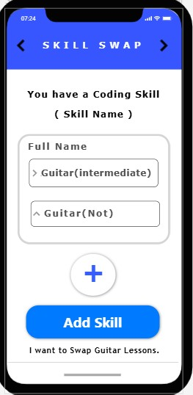

Add Skill Screen (Add Skill Button + Plus Icon)
Why Familiar?
- “+” button is commonly used to add something.
- Form-style layout (Full Name / Skill Name) is standard.
- Looks like profile editing page in many apps.

Screen 3 :

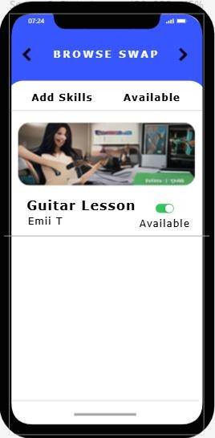
Browse Swap Screen (Skill Card List)
Why Familiar?
- Card layout with image + title is very common (like shopping apps).
- Toggle “Available” switch is also common in apps.
- Looks like marketplace browsing screen.

Screen 4 :
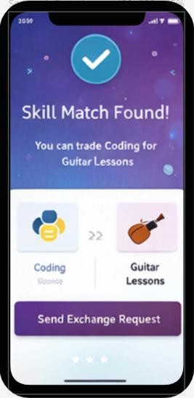
Skill Match Found Screen – Unfamilier Why Unfamiliar?
- Special match animation screen.
- Shows exchange comparison (Coding ↔ Guitar).
- Not a regular screen like login or list.

Screen 5 :

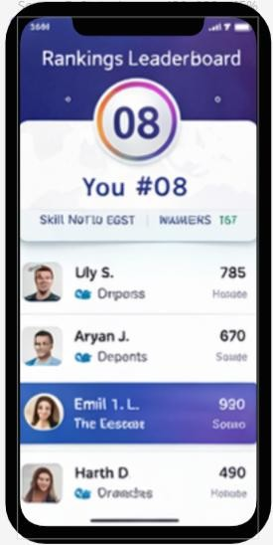
Rankings Leaderboard Screen - Unfamilier

Why Unfamiliar?
- Leaderboard ranking system is not in all apps.
- Shows rank number (#08) and scoring.
- More like a gamification feature.

Prototype Link :
https://pr.to/T31I42/

